**Lab 5:**

**Aim: Study and Analyze the Kirchoff’s Voltage Law**

**Task**. Calculating voltages across each resistance using Kirchoff’s Voltage Law

2. Find total numbers of loops and equations for KVL

Note: Design the circuit on electronics workbench and logic trainer with available resistances value.

# Material

* Resistors
* Multi-meter
* Voltage source

# Procedure

1. We took resistors and constructed a series-parallel circuit as shown below.

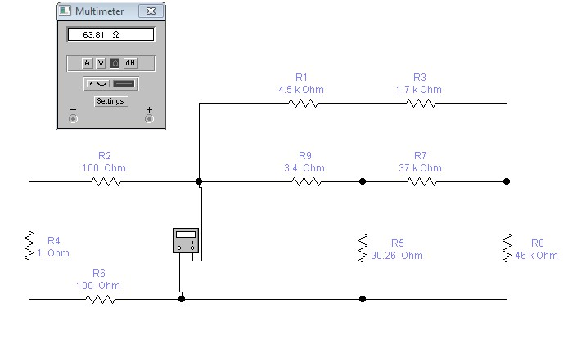

1. Identified points between which voltage can be measured.
2. In the given drawing, these are A-B, B-C, C-D, A-E, E-F, A-I, I-G, I-K, F-G, H-K, K-D and G-H.
3. The measured voltages are indicated as VAB, VBC, VCD, VAE, VEF, VAI, VIG, VIK, VFG, VHK, VKD and VGH.
4. The subscript of each voltage signified that the first alphabet represents the point which is assumed to be positive and the second point represents the point which is assumed negative with respect to the first point.
5. The voltages between all of these points were measured with red probe connected to first point in the subscript and black probe connected to second point.
6. The voltages may also be measured by interchanging the probe position between any two points.
7. Measured and noted all these voltages.
8. These are equations for KVL within loops

**Loop ABCDA**

VDA + VAB + VBC + VCD = 0

**Loop AEFGA**

VAE + VEF + VFG + VGA = 0

**Loop AIKDA**

VAI + VIK + VKD + VDA = 0

**Loop IGHKI**

VIG + VGH + VHK + VKI = 0

**Loop AGHDA**

VAG + VGH + VHD + VDA = 0

**Loop EFHDE**

VEF + VFH + VHD + VDE = 0

# Loop AEFHCBA

VAE + VEF + VFH + VHC + VCB + VBA = 0

**Verification**

# Loop ABCDA

VDA + VAB + VBC + VCD = 0

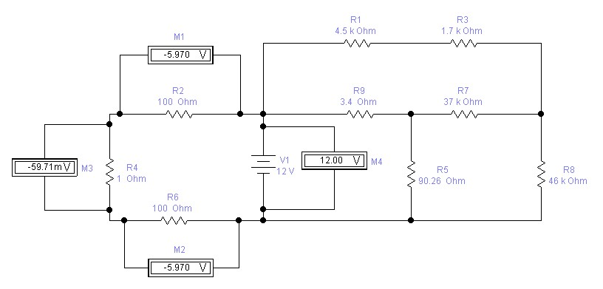

# Loop AEFGA

VAE + VEF + VFG + VGA = 0

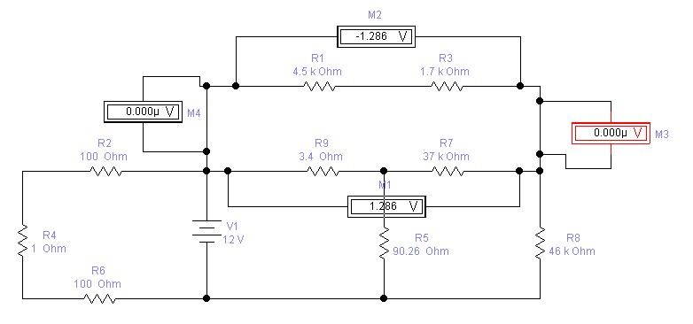

# Loop AIKDA

VAI + VIK + VKD + VDA = 0

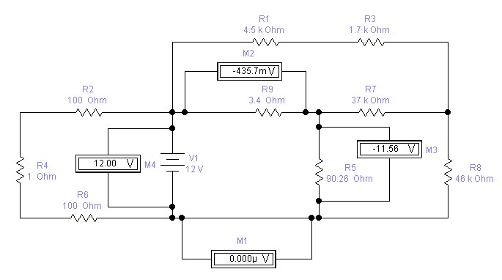

# Loop IGHKI

VIG + VGH + VHK + VKI = 0

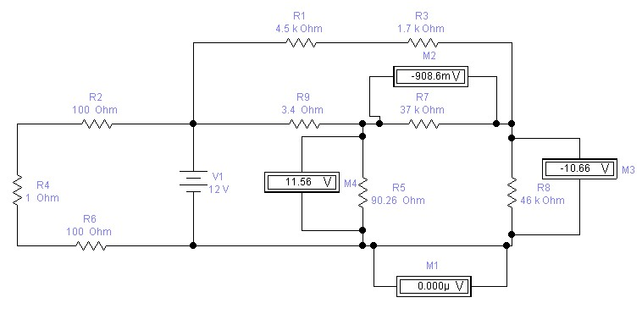

# Loop AGHDA

VAG + VGH + VHD + VDA = 0

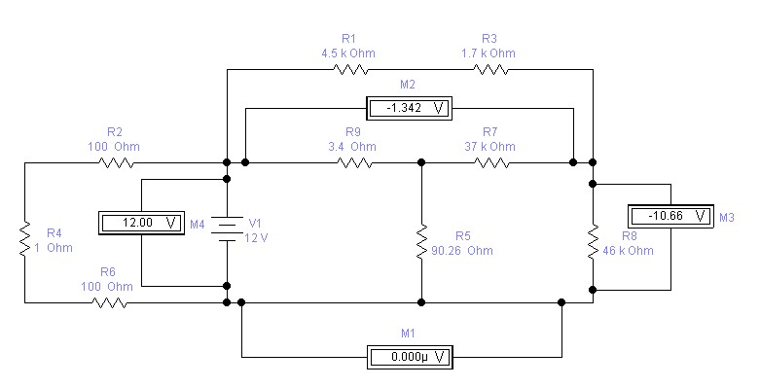

# Loop EFHDE

VEF + VFH + VHD + VDE = 0

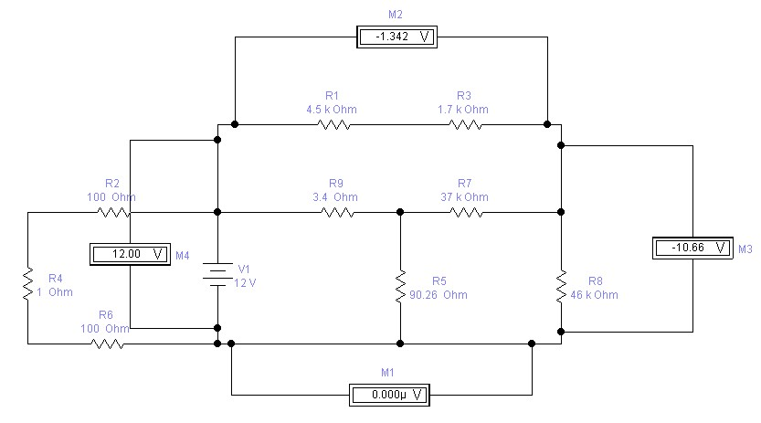

# Loop AEFHCBA

VAE + VEF + VFH + VHC + VCB + VBA = 0

INSTRUCTOR VERIFICATION SHEET

For each verification, be prepared to explain your answer and respond to other related questions that the lab TA’s or Instructors might ask.

Name: Date of Lab:

Q. No. 01

Q. No. 02

## Q. No. 03

Verified: Date/Time: